**Final Project**

**Task 1:**

**LAB -1**

Steps:

1. Use Burp Suite to intercept and modify the request that sets the product category filter
2. Modify the **category** parameter, giving it the value **'+OR+1=1--**
3. Submit the request, and verify that the response now contains one or more unreleased products.

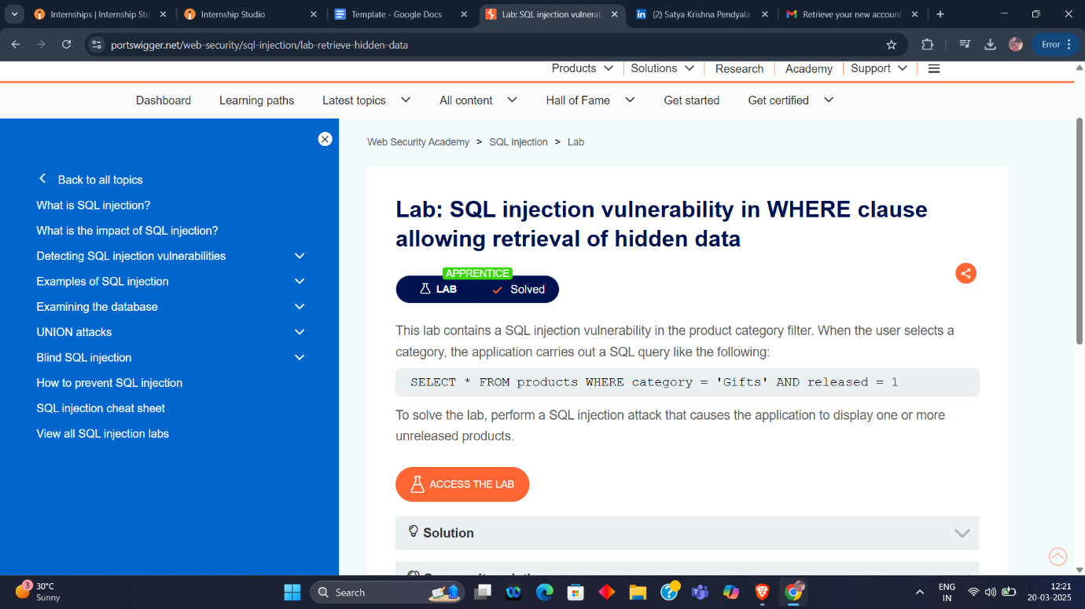

**LAB -2**

Steps:

1. Use Burp Suite to intercept and modify the login request.
2. Modify the **username** parameter, giving it the value: **administrator'—**

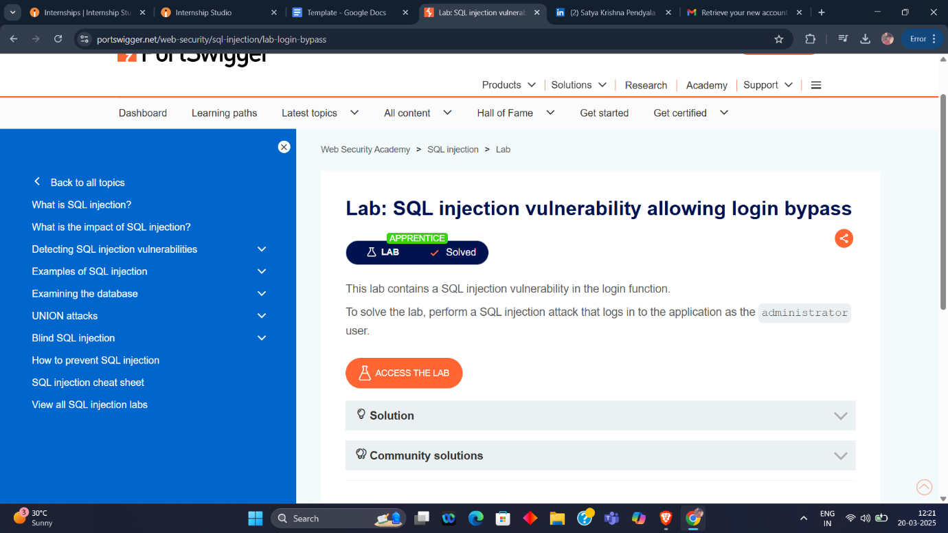

**LAB -3**

Steps:

1. Type the following into the search box:

**<script>alert(1)</script>**

1. Click "Search"

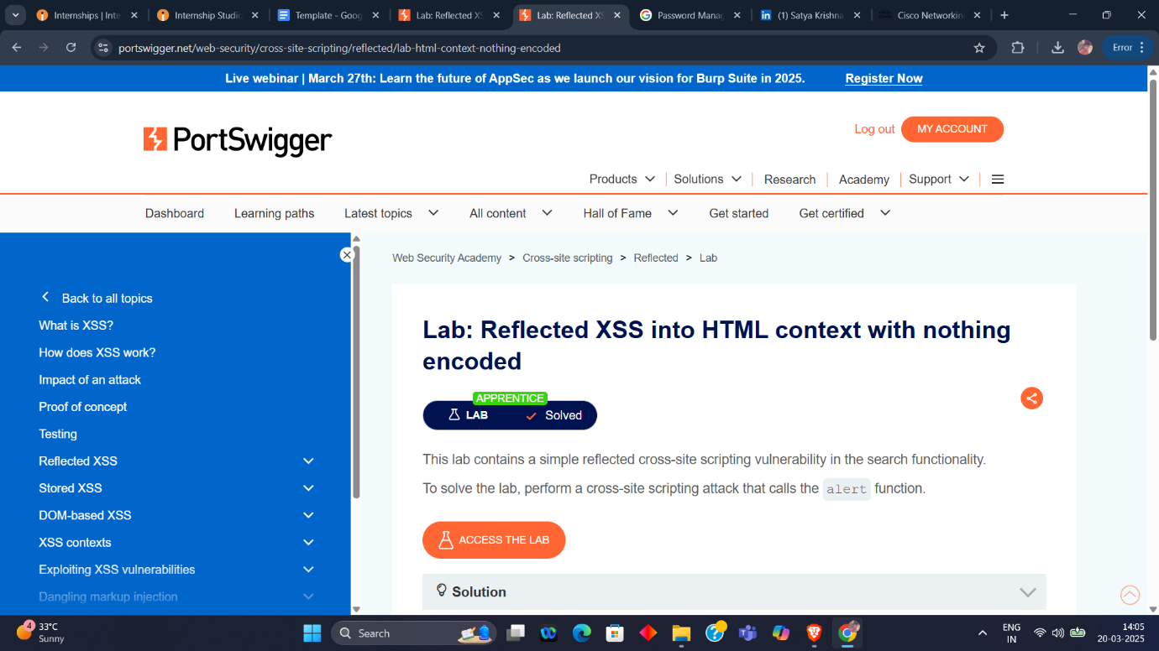

**LAB -4**

Steps:

1. Enter the following into the comment box:

**<script>alert(1)</script>**

1. Enter a name, email and website.
2. Click "Post comment".
3. Go back to the blog.

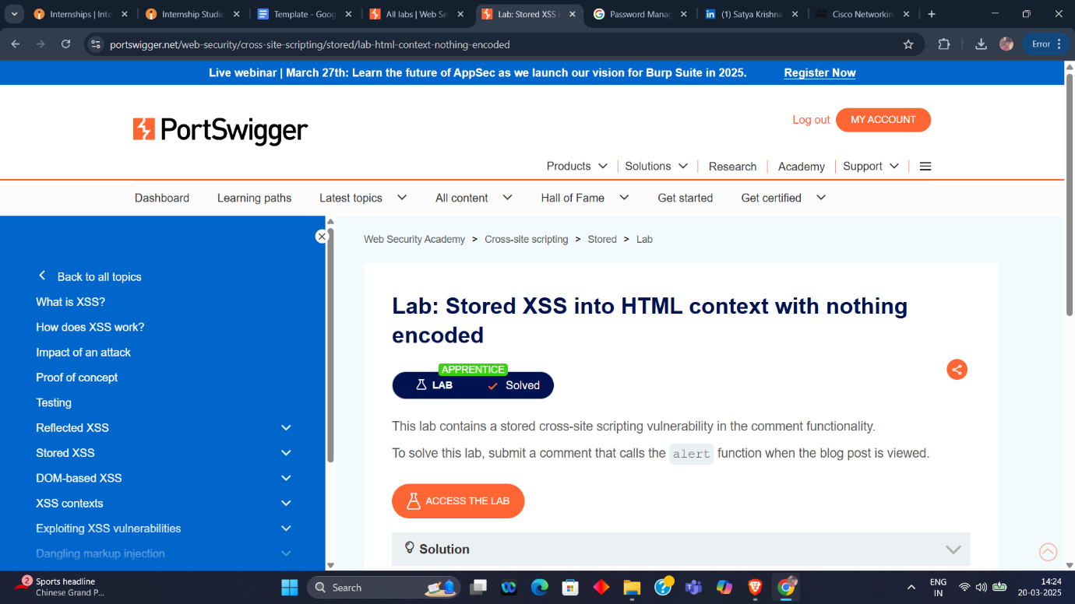

**LAB -5**

Steps:

1. Enter a random alphanumeric string into the search box.
2. Right-click and inspect the element, and observe that your random string has been placed inside an **img** **src** attribute.
3. Break out of the img attribute by searching for:

**"><svg onload=alert(1)>**